1. Design PDA using simulator to accept the input string anbn

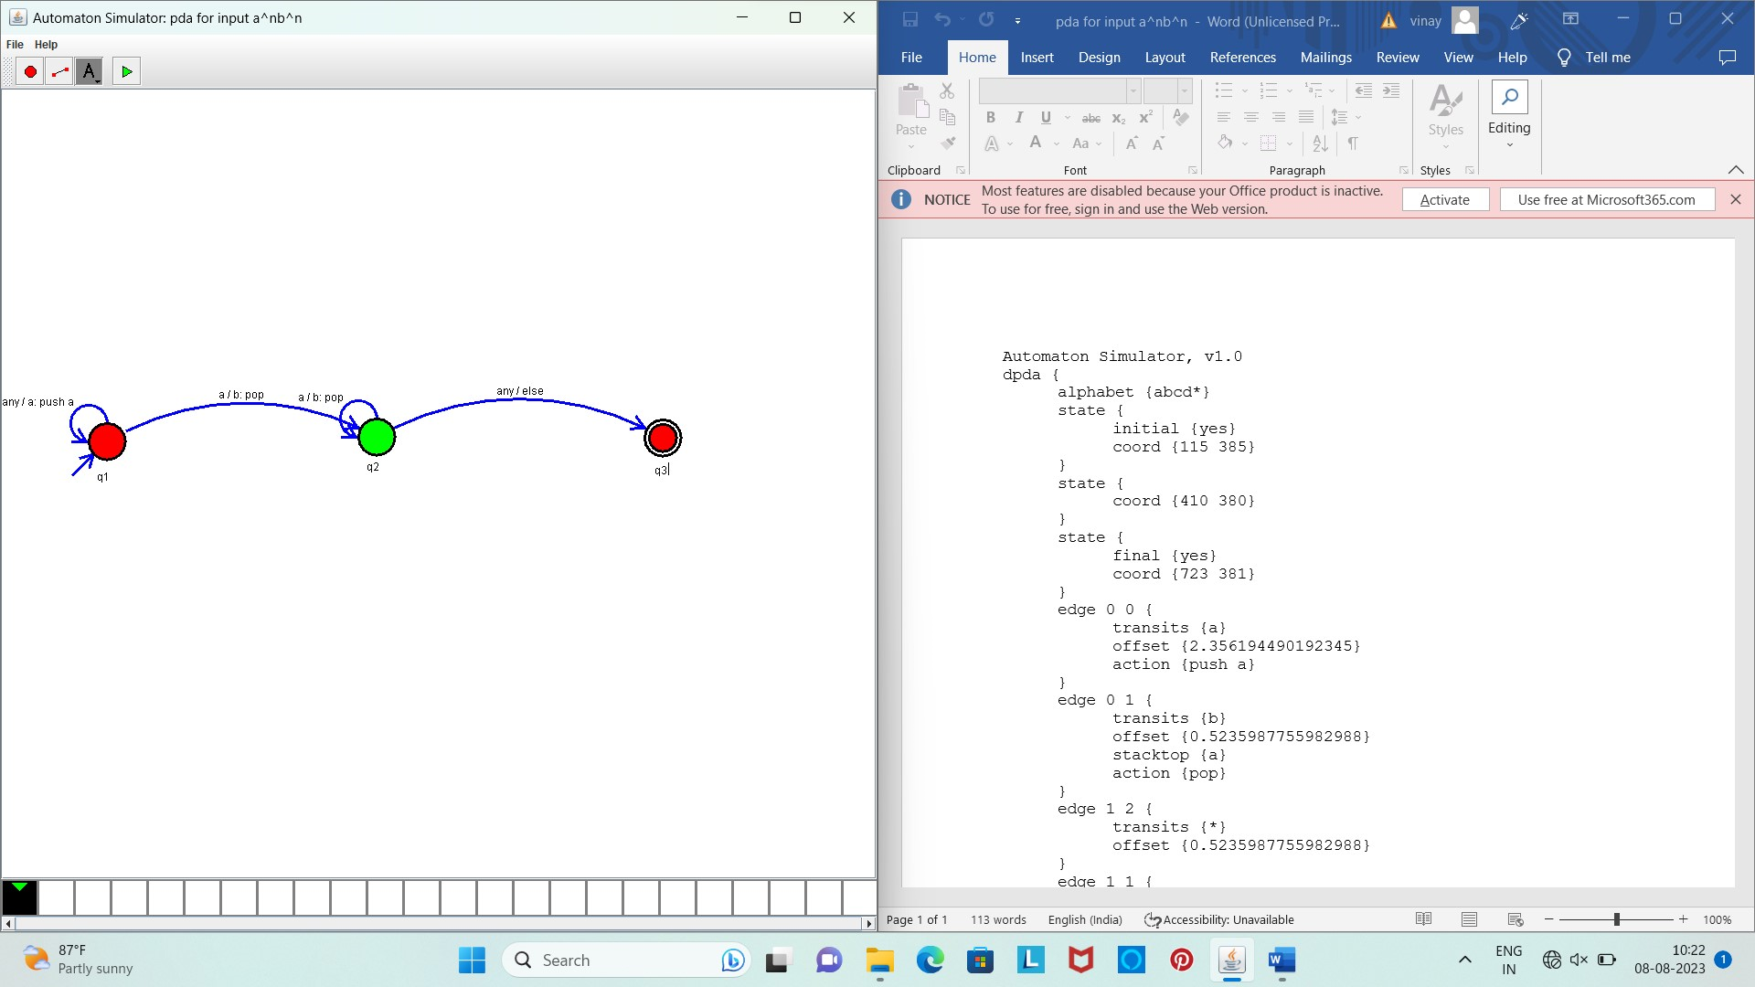

Result:

The given input string is accepted by the simulator by using the above PDA diagram